**07/09/2021 CD LAB 1 2019103573**

**WEEK 1**

**LAB PRACTICE SESSION**

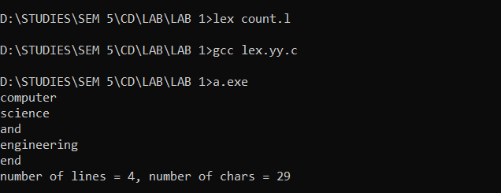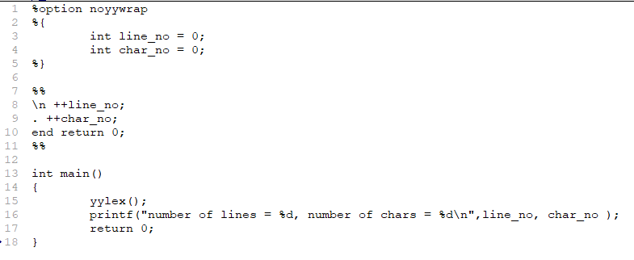**1. Write a lex program to count the number of character and lines.**

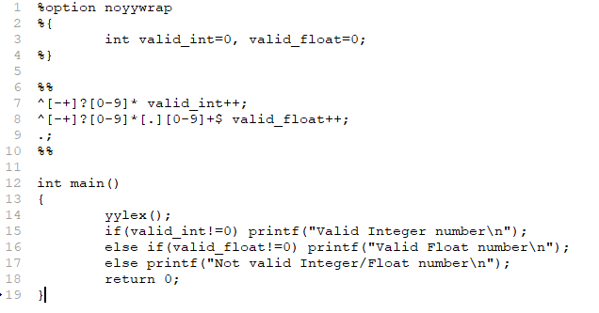**2. Write a lex program to recognize the valid Integer / Float.**

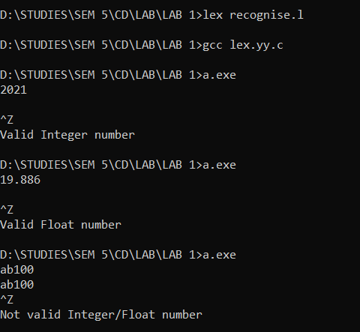

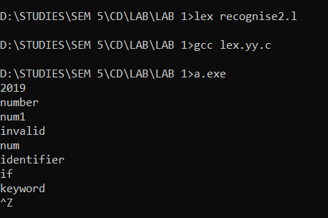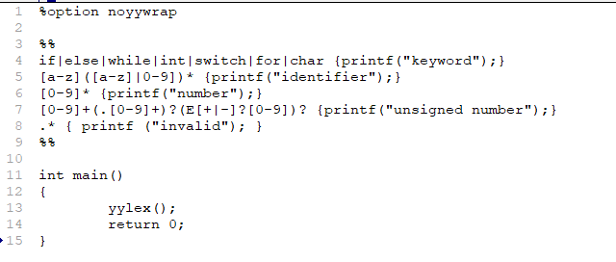**3. Write a lex program to recognize identifier, keyword, number and unsigned number.**

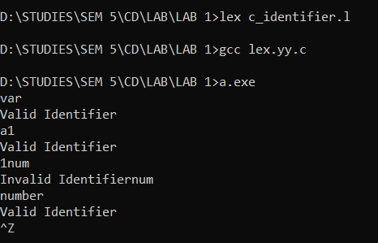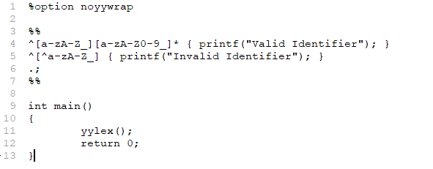**4. Write a lex program to determine whether the input is “C Identifier or not”.**